Azure Course Notes:

Azure Functions:

How to select:

Regions:

1) Proximity to target audience

2) Service availability: 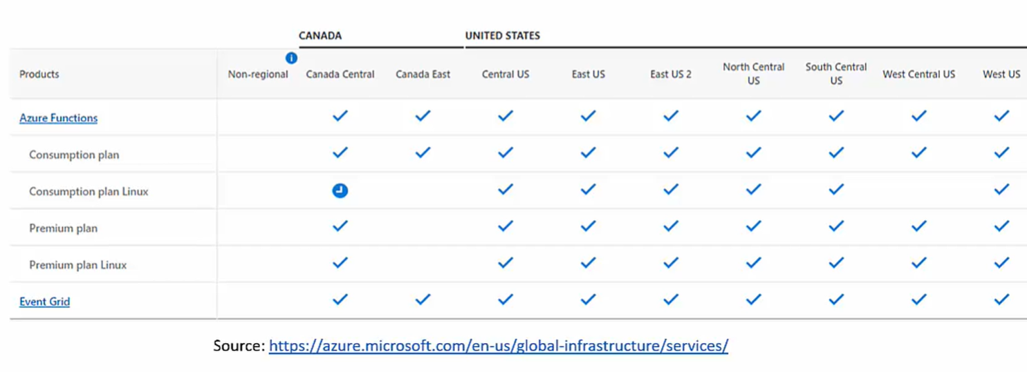

3) Availability Zone: More than one data center

4) Pricing: Cheaper in US than Norway

Resource Groups: Free

Logical container for resources:

Separation can be done based on teams or dev, uat, prod or anything else that you like.

Every resource is placed in a RG

Try to put one vm in one resource group so that its easy to delete its dependent resources(disk, ip address etc) all together at once

Subscription: is also logical container for resource groups

It Associates accounts

Cost center because costing is always per subscription.

Management groups containers for subscriptions (easy to manage subs).

Directory = Tenant

Storage Account:

Store anything

Cheap

SLA: Service Level Agreement

It is the Uptime % of a cloud service

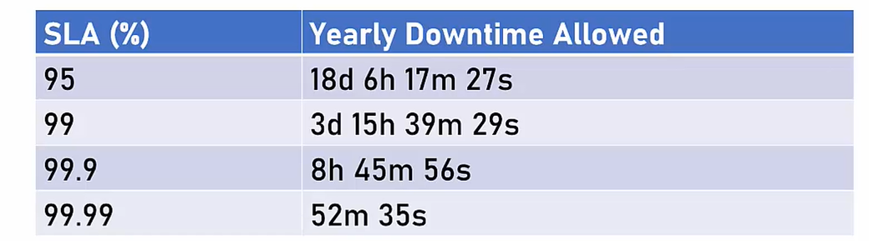

Cost:

Always check cost of a resource.

Check for cost effective alternates

Reservation pricing model gives hefty discounts

Azure pricing calculator is a great tool.

Virtual Machines:

Pricing - ~$80/month linux

Azure SQL Database:

Pricing - ~$700/month

A virtual not real server running on a physical real server

Allows creation of new servers really quick

Based on existing resources of the physical server

From users point of view, its like a normal server

Called Unmanaged Service because Azure has nothing to do with whats happening inside the server. You are responsible for any faults.

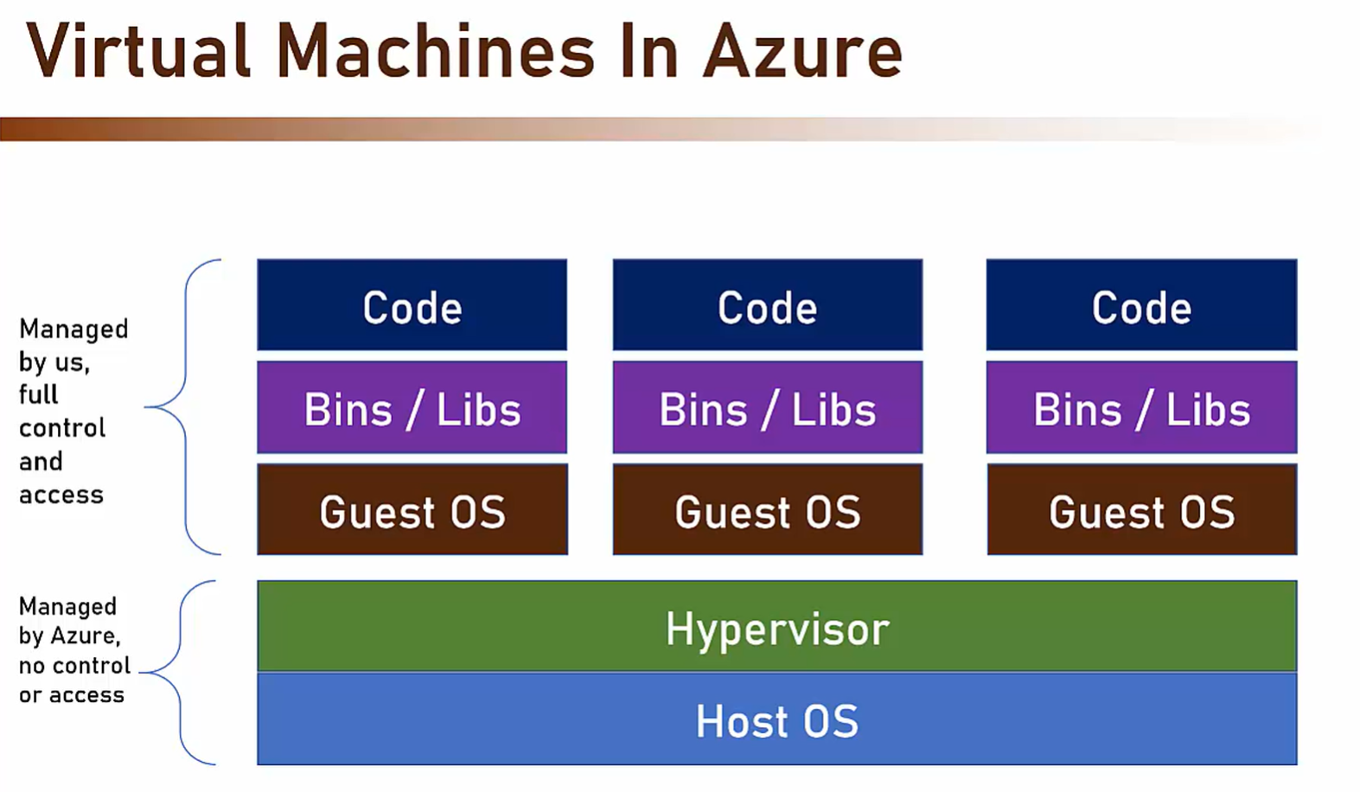

What is an Image: OS + some pre installed software.

Setting Budget:

Use Cost management tool

Azure compute:

Set of cloud services for hosting and running applications

Allows uploading your code and then running it

Offers various levels of control and flexibility

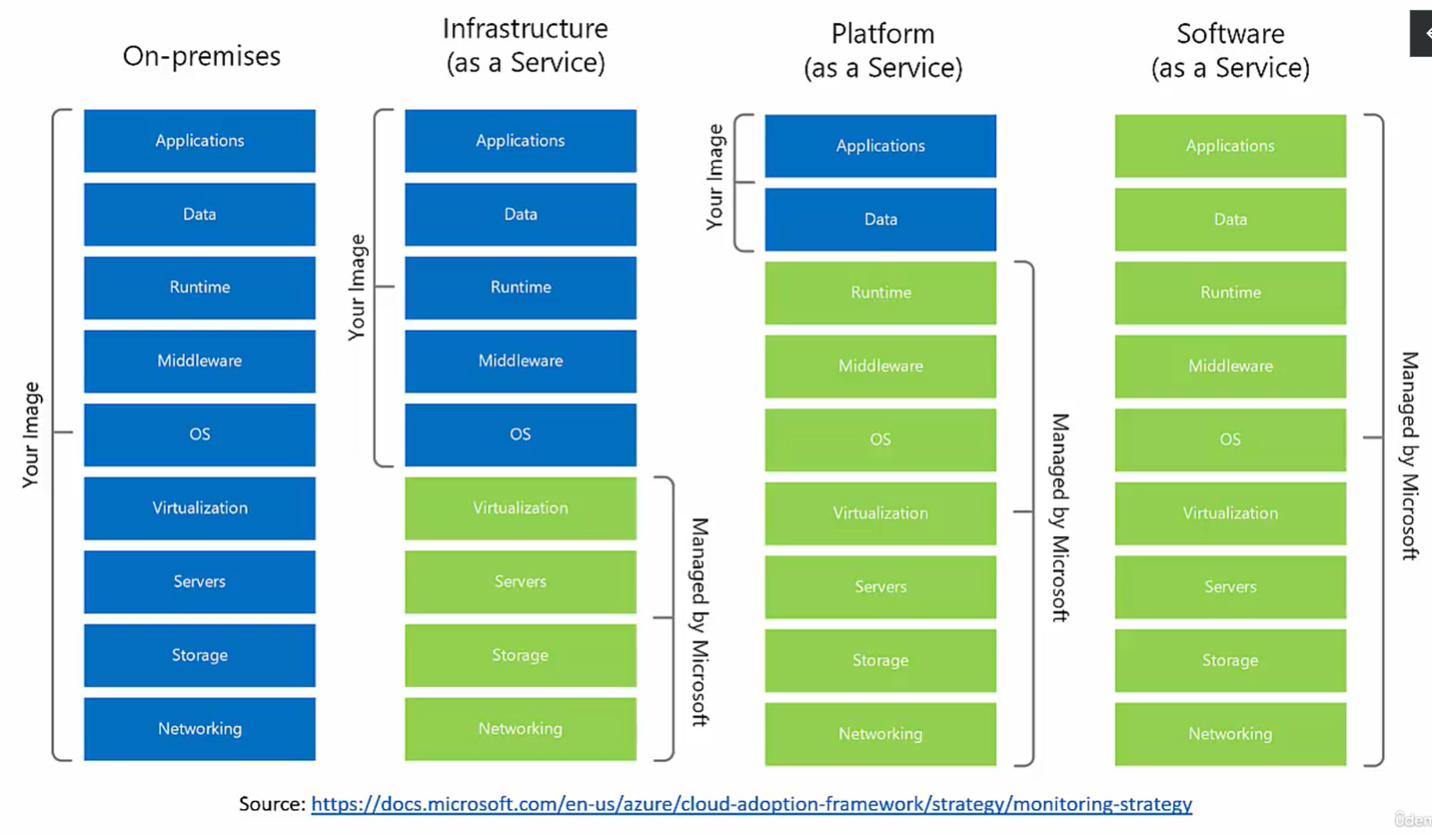

Cloud services and differences in control IaaS, SaaS, PaaS

Real cost of VM:

VM

Disk

IP

Storage, where the image of the VM is stored. Its stored in a storage account which we don’t know about.

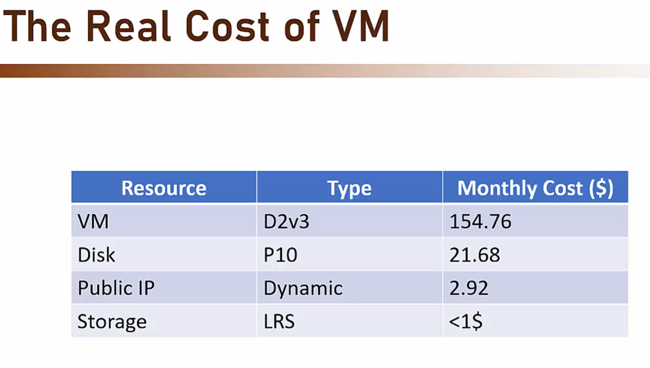

Reducing cost of VM:

Auto Shutdown: Auto shutdown machine when not needed, storage and ip costs are still incurred. Used mainly for dev/test tasks

Reserved Instances: Pay upfront for specified duration of time reduce cost by 50%. Great for production machines. Cannot be stopped or refunded

Spot Instances:

• Machines that run on unused capacity in Azure

• Can be evicted any moment when needed by Azure

• Offers up to 90% discount, price fluctuates according to demand

• Great for non-critical, non-continuous tasks • ie. Batch processes, long running calculations

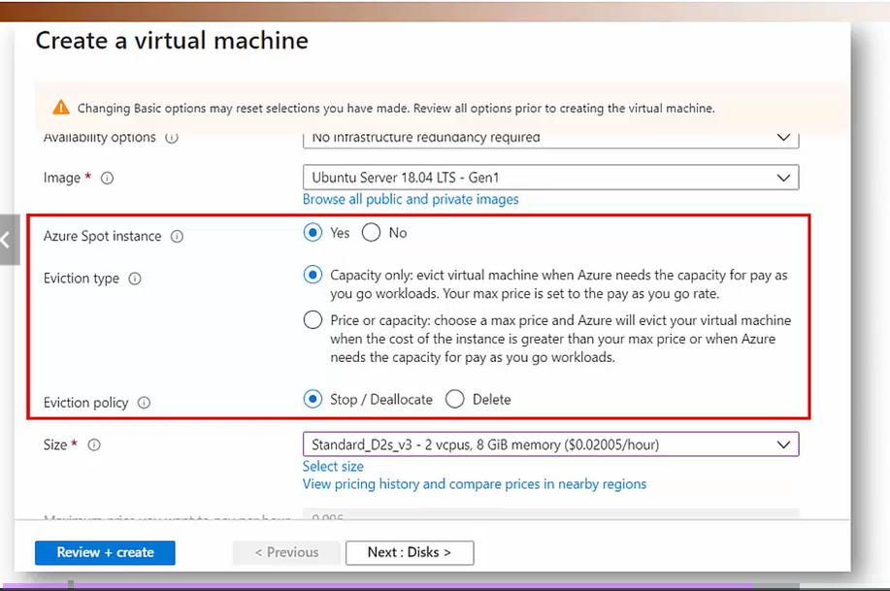Disk Optimization:

• Make sure to select the right disk for the machine

• Default is Premium SSD - the most expensive option

• Non 10-intensive machines can do with Standard SSD

• ie. App servers, in-memory cache

• Note: Disk type affects the SLA

More Cost Saving Techniques • Select the right size for your machine • CPU shouldn't rest, you pay for it® • Select Linux over Windows when possible • Check price in nearby regions

Availability Concepts:

Fault Domain: If there's a problem with the power or networking in the domain (=rack) - all servers in it shut down You want to make sure your servers are spread across more than one fault domain (=rack)

Update Domain: If all your servers are in the same update domain - they'll reboot at the same time during maintenance You want to make sure your servers are spread across more than one update domain

Taking Advantage of Availability Set: • Deploy identical VMs into the same Availability Set • Ensures they won't be shut down simultaneously when a single fault domain shuts down or an update domain reboots If needed - deploy load balancer to route between the VMs Availability Set is free, you pay only for the additional VMs

Taking Advantage of Availability Zone: • Deploy identical VMs into separate Availability Zones in the same Region • Ensures they won't be shut down simultaneously when the zone shuts down • If needed - deploy load balancer to route between the VMs Also free, you only pay for the additional VMs

ARM Template: • Azure Resource Manager Template • A JSON file describing the resources) to be created • Used by Azure in (almost) all deployments • Can be exported, modified, uploaded, deployed • Can also be created from scratch

• ARM Template is a declarative way of deploying resources

Declarative: • Describes the end result • Allows "What-If" operation • Can deploy multiple resources at once • Can be integrated in CI/CD processes • Can be source controlled

Imperative: • Sends instructions to run • Error prone • Can't be verified • Can't be source controlled • Suited for quick and dirty operations

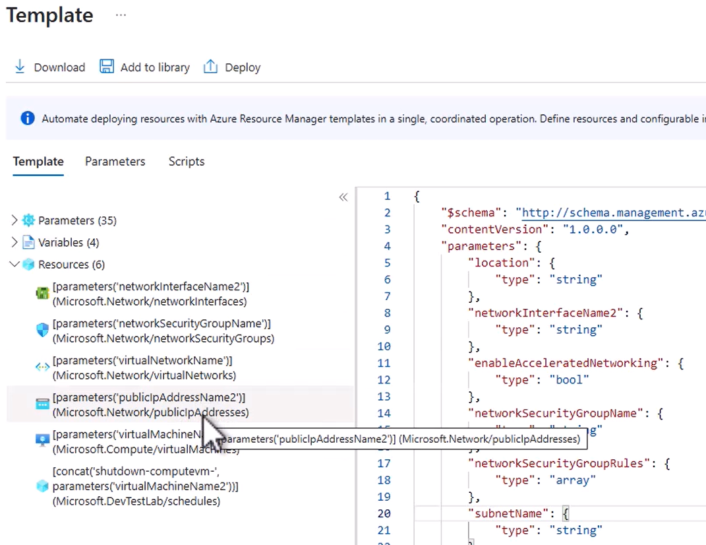

Arm template deploy button in the UI will only deploy the resources and not the parameters.

To deploy the parameters, upload the arm template and the parameters file in a fileshare in a storage account(can use storage account created when you first started the cloud shell) -> Create a new rg where you want the vm to be created. Use the cloud shell and write some commands:

1. cd clouddrive: cloud shell storage account drive
2. cd templates
3. dir: you should see your uploaded template files
4. az deployment group create --resource-group optimized-vm-rg --template-file template. json --parameters parameters. Json

This should create the vm with the necessary parameters. Can use arm templates or portal to commission resources.

Deleting VMs: always select which associated resources you want to delete along with the VM

Virtual Machine Scale Set: Free, pay for vms. • A group of separate VMs sharing the same image • Managed as a group • Can be scaled out or in manually or according to predefined conditions • Great for handling unpredictable load

Virtual Machine Scale Set • Once set up, the machines should NOT be modified • Change files, install apps etc. • New machines created by the scale set will be based on the original image i.e changes will be lost if it is scaled up or down. Make changes in the original image for it to reflect it in all vms • For web apps, a load balancer should be put in front of the scale set.

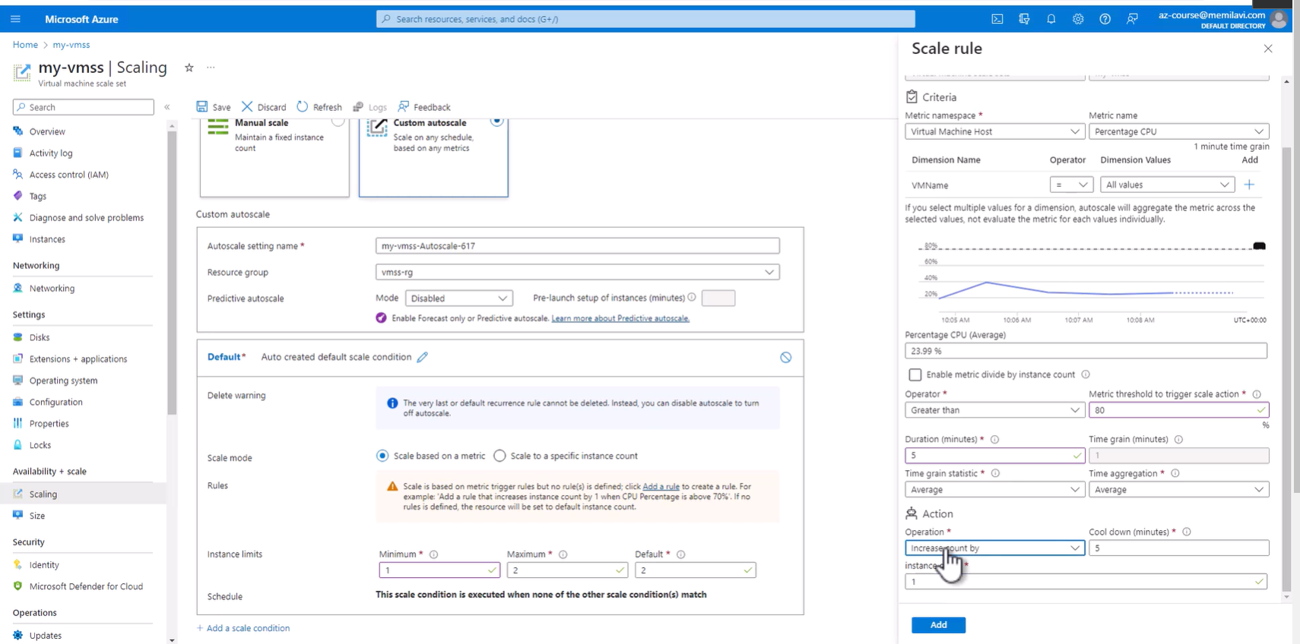automatic scaling in a vmss.

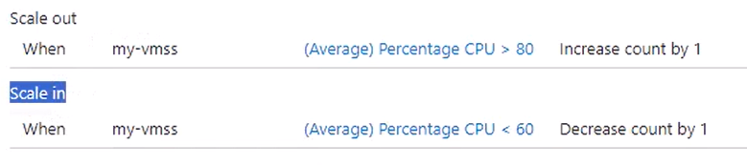

az provider show --namespace microsoft.insights -o table: to check if a resource provider was registered or not for the vmss or anything while saving scaling policy.

App Services:

• A fully managed web hosting for websites

• Publish your code - and it just runs

• No access to the underlying servers

• Secured and compliant

• Integrates with many source controls and DevOps engines: App Services • GitHub, Bitbucket, Azure DevOps DockerHub and more

Supported platforms: • NET • .NET Core • Node.JS • Java • Python • PHP • Supports containers

App Types:

• Web Apps • Web API • Web Jobs (batch processes)

• Extremely easy to deploy:

1. ­Develop your app 2. Create Web App (can be done from the IDE) 3. Publish your code 4. Viola!

<https://azure.microsoft.com/en-us/pricing/details/app-service/linux/>: app service tier pricing details  
Approx 25$/month for the cheapest hosting option. Explore Netlify and other hosting options.

App service can be autoscaled as well

Deployment Slots:

• When uploading code to App Service the new version is accessible immediately

• Sometimes we want to test the version before publishing it

• Deployment Slots allow us to upload code and test it separately from the main site

• After validation we swap the slots and promote it to production

• New slots are created from the portal Number of allowed staging slots depends on plan • ie. Standard plans allow for up to 5 staging slots

• Slot is a fully functional app service with a dedicated URL Slots can be accessed directly through their URL

* Free

• Traffic can be split between slots

• Some users will be routed to the production and some to the new slot

• Great for some deployment scenarios

When you split traffic between two deployment slots, azure creates a cookie the first time you access the website which specifies which slot you visited. Azure then will always route you to that same slot instead of another one.

While creating a deployment slot, ‘Clone other settings’ option does not replicate the app running on another slot, it just replicates some of the settings. This option can be left to ‘Don’t Clone’ without any problems.

Types of Deployments:

Basic Deployment: All instances update to the new version at the same time

Pros:- Simple, Fast

Cons:- Risky, System might become unusable

Application:- in App Services, not using deployment slots and just updating prod will signify Basic Deployment strat

Rolling Deployment: • Instances are updated gradually in batches • Only if no errors are found the deployment resumes

Pros:- Allows Rollback

Cons:- Need to support two versions simultaneously, Difficult to manage

Application: • Deploy to slot • Set traffic percentage so that small % will be routed to the new version Gradually increase % of traffic to new version until 100%

Blue-Green Deployment: • New version uploaded and accessible only to testers • After verification complete, traffic is routed to new version

Pros:- • Simple • New environment is always tested

Cons:- • Cost • More instances

Application: • Deploy to a new slot • Testers work on the new slot using its dedicated URL • After testing is complete - swap slots

* By default, App Services can be accessed using http and https. You can make it https only in the TLS/SSL settings in the App Service menu.
* App service can run also batch processes, or continuous jobs, and not only web apps with the request / response  paradigm. This can be done using the WebJobs menu item, where you can upload exe file that will run always, or on scheduled times.
* Want to know the IP address of the App Service? Take a look at the Properties of the page. You can find there the Virtual IP address of the App Service, and also - the Outbound IP addresses. Note the plural - App Service can have more than one outbound IP address.
* Want to know how much storage did you use, and what are the current usage statistics? Go to Quotas for this data.
* **Shutting Down App Service**
* With VMs, I recommended you to shut down the VM when not in use.
* With App Service, this is not the case. While you can stop an App Service (using the Stop button at the top of the Overview page), all it will do is to stop the functionality of the App Service, but you'll still pay for it.
* That's an important difference between App Service and a VM.
* With VM - you pay only when the VM is On.
* With App Service - The only way to stop paying for it is to completely delete it.
* This is another difference between VM and App Service you should keep in mind.

Azure Container Registry:

You may get a 401 unauthorised error in Azure Container Registry:

In order to avoid this error please follow these steps:

1. In the menu on the left click **Access control (IAM)**

2. Click **+ Add** -> **Add role assignment**

3. Switch to the **Privileged administrator roles** tab

4. Select the **Contributor** role and click **Next**

5. Click **+ Select members** and select your user from the list

6. Click **Select, Review + assign, Review + assign** again, and after assignment is complete go again to **Repositories**, and this time you won't see the error.

Azure Functions:

• Small, focused functions running as a result of an event • Great for Event Driven systems • Automatically managed by Azure - Start, stop, autoscale • Flexible pricing plans • Serverless

Serverless meaning • Cloud resource that is completely managed by the cloud • Users do not need to think about: • VMs • CPU • Memory • etc.

Triggers and Bindings:

Triggers: • The event that made the function run • Quite a few • Deeply integrated into other Azure services • Technically not mandatory, but...

Bindings: • Declarative connection to other resource(s) • Input, output, or both • Provided as parameter to the function • Makes connecting to other resources extremely easy • Not mandatory

Trigger Types • Blob Storage • Cosmos DB • Dapr • Event Grid • Event Hubs HTTP Requests • IOT Hub • Kafka • Queue Storage • RabbitMQ • Service Bus • Timer

Binding Types (Input or Output) • Blob Storage • Cosmos DB • Dapr • Event Grid • Event Hubs • HTTP Requests • IOT Hub • Kafka • Mobile Apps • Notification Hub • Queue Storage • RabbitMQ • SendGrid • Service Bus • SignalR • Table Storage

Triggers and Bindings • Example scenarios: • Run every 5 minutes (Timer Trigger) and calculate the sum of a column in a DB. If it's above 115, send an event in EventGrid (Binding)

• Example scenarios: • When a message arrives in the Orders Queue (Queue Trigger) save it in Cosmos DB (Binding) for future handling

• Example scenarios: Receive HTTP Request (HTTP Trigger) with 4 numbers, and return the smallest one of them (no binding)

Supported Languages • C# JavaScript (nodeJS) Java Python PowerShell F#

Cold Start • Azure Functions are completely managed by Azure • After some time of inactivity Azure might take down the Function's host • The next activation of the Function will take time 2-3 seconds before the code runs • A problem mainly for HTTP-Triggered functions

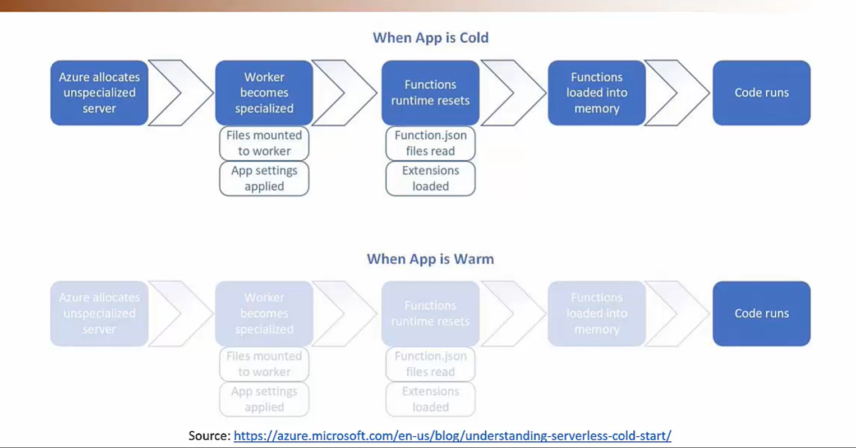

Avoid Cold Starts by selecting the right hosting plans

Hosting Plans Functionapps:

Consumption Plan: limit of 1.5 gb ram only, cold start problem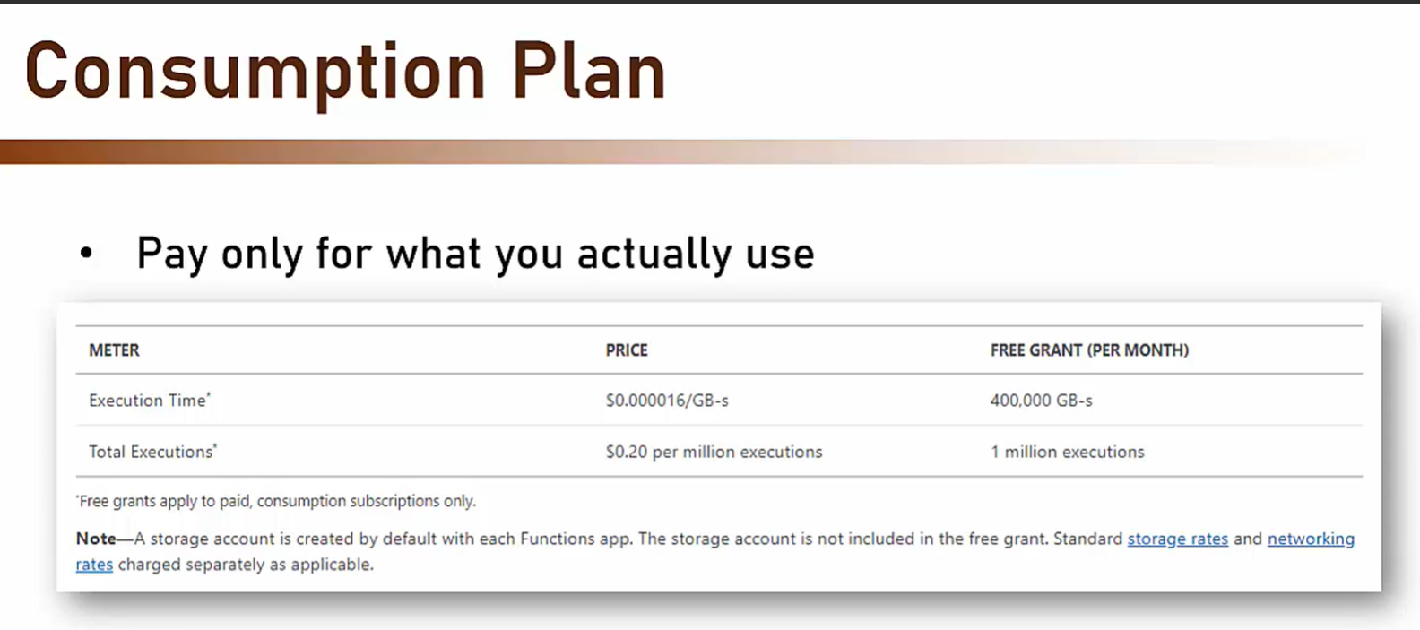

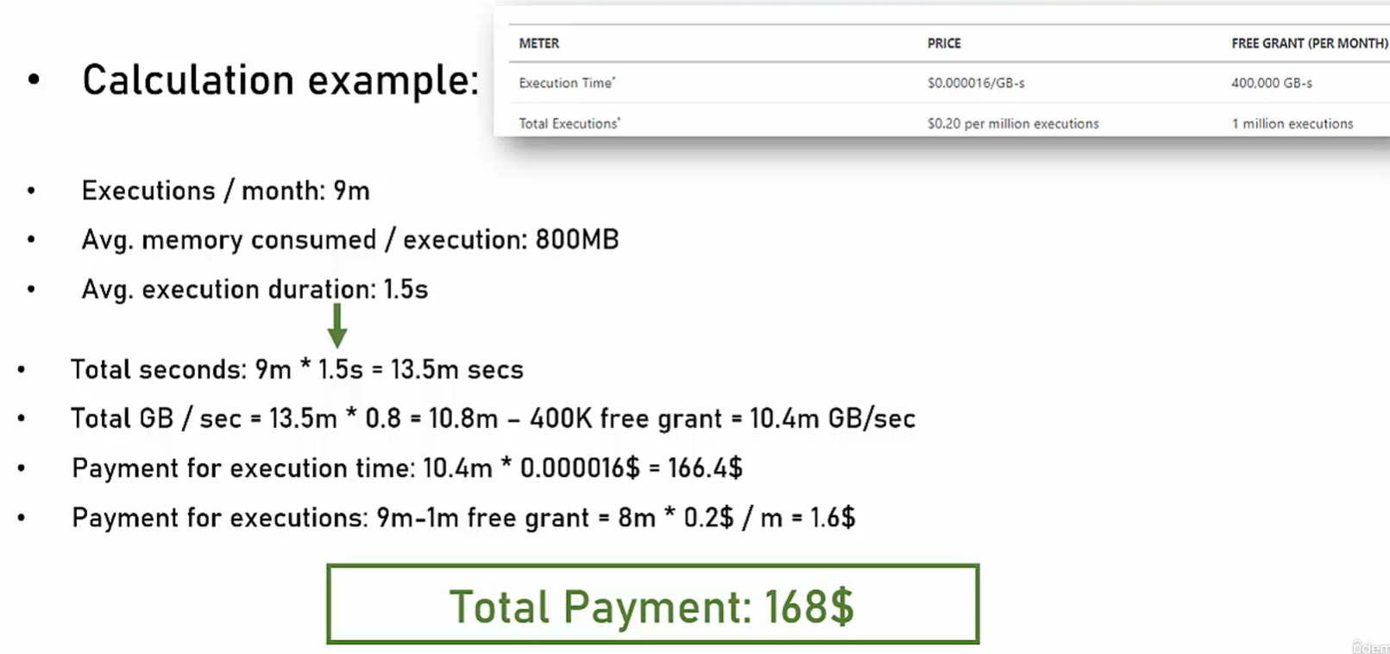

Premium Plan: Pay for pre-warmed instances

• What you get: • No cold starts • No memory limit (up to capacity of your selected host RAM) • Better performance • VNet integration(good security feature)

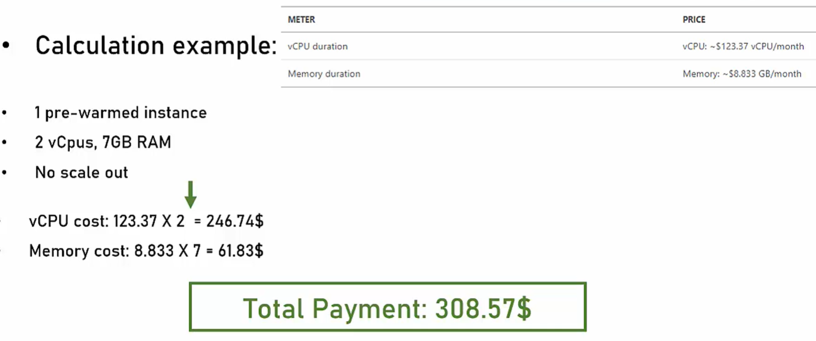

Figure Calculation example for a premium plan

Dedicated Plan • The Functions run on an existing App Service • Great if server is under-utilized • No additional costs

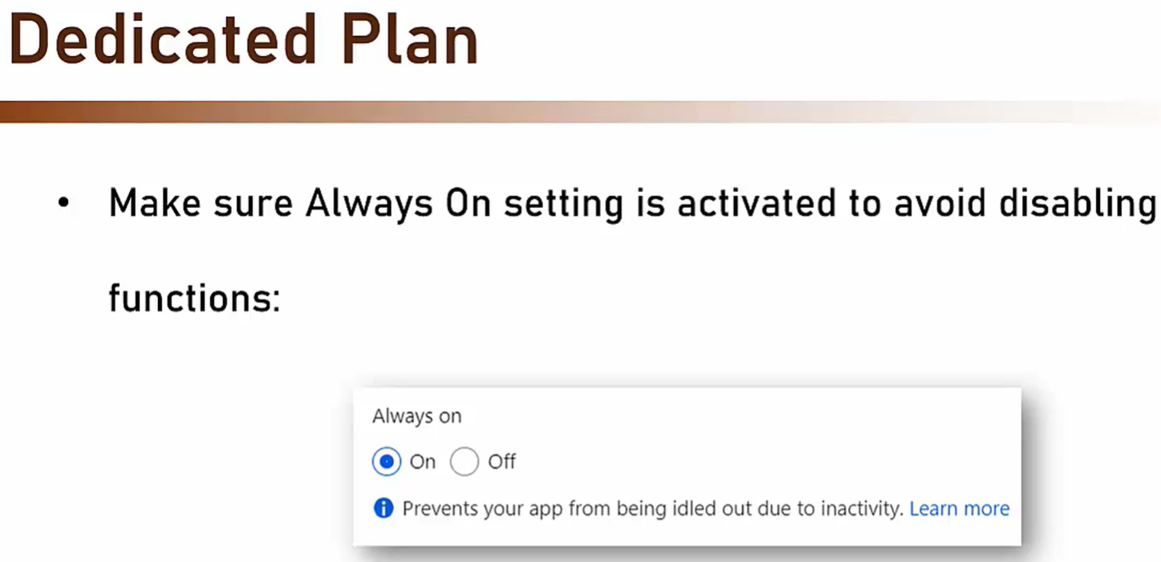

Only one drawback: No Auto Scaling

Special Functions called Durable Functions:

Durable Functions:

• Stateful Functions that interact with external resources and keep track of flow

Offer very simple syntax, hide complexities of managing state, retries, etc.

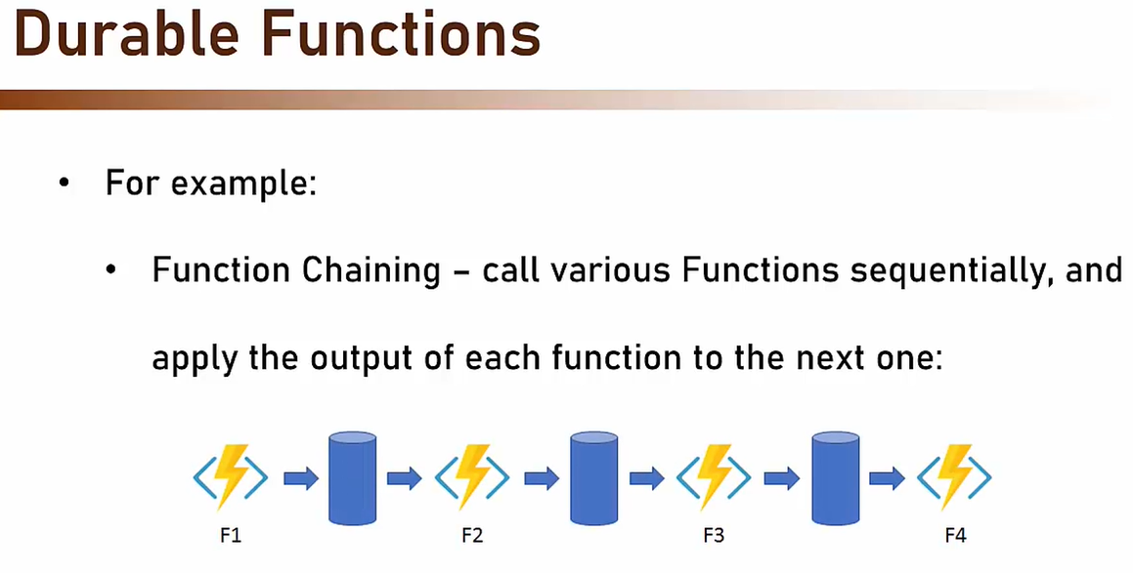

Can run azure functions locally by installing the azure functions core tools cli

How to choose Which Compute type to use:

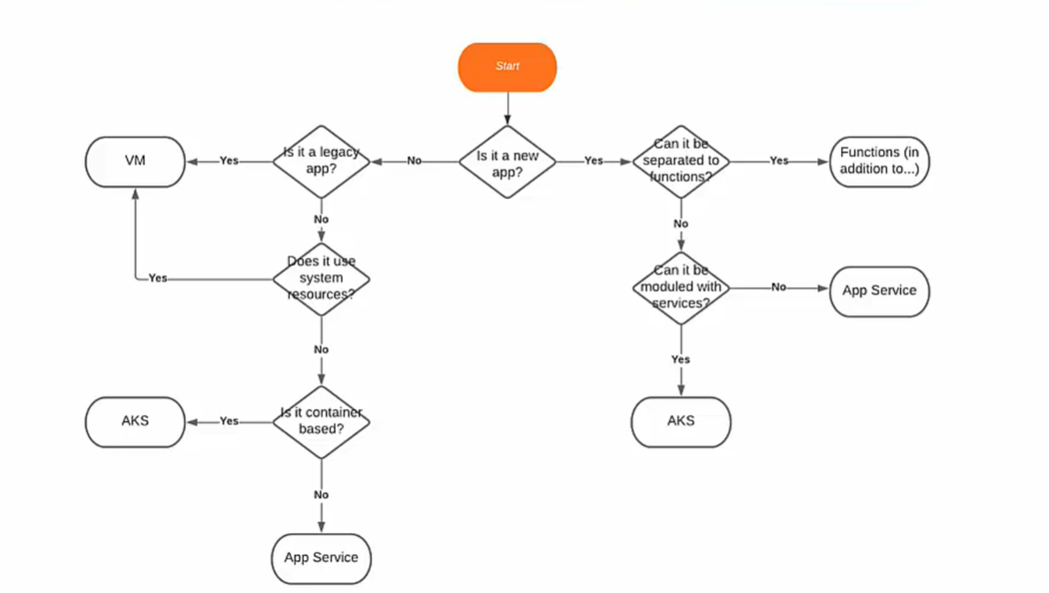

Networking in Azure:

Networking knowledge is what makes a good cloud architect - an amazing cloud architect

Virtual Networks:

Logical grouping of resources in a network. Think of it as your private network.

vnets are free but there is limit of 50 vnets per subscription across all regions.

Scoped to a single Region • Cannot span multiple Regions • Scoped to a single Subscription • Can be connected via Peering. Segmented using Subnets. Protected using NSG

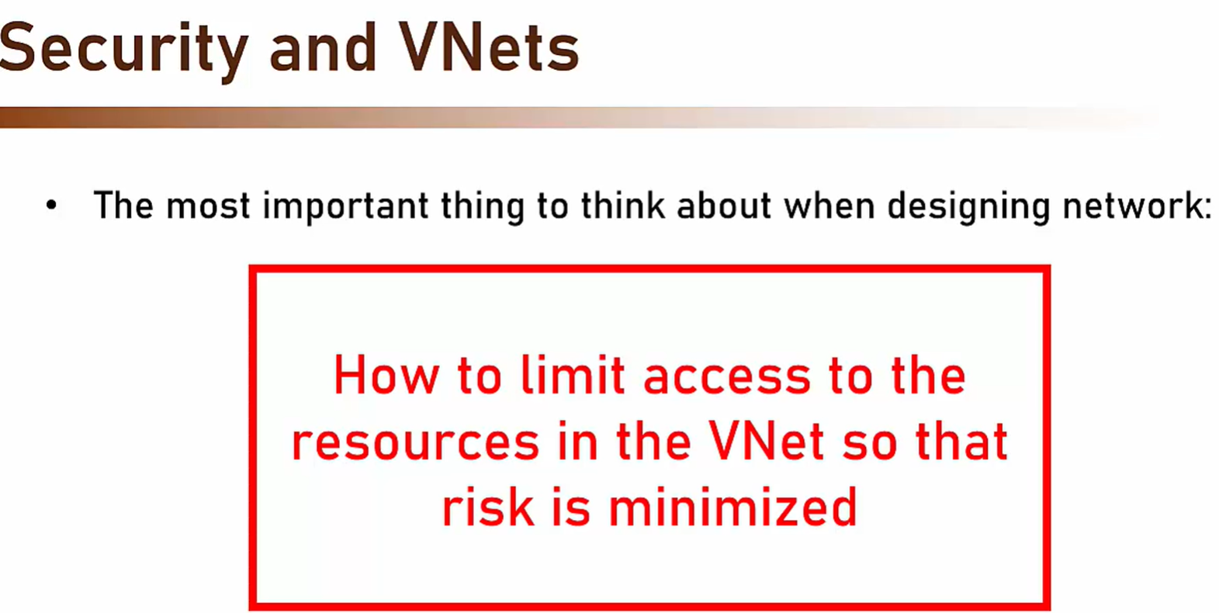

Addresses of VNets • Each VNet has its own address range • Or IP Range By default - 65,536 addresses Can be customized All network devices must be in this address range Characteristics of V Expressed using CIDR Notation

CIDR Notation • Classless Inter-Domain Routing • A method for representing an IP Range • Composed of an address in the range and a number between 0 and 32 The number indicates the number of bits that are allocated to the CIDR Notation • Mura get reas address. The smaller the number - the larger the range

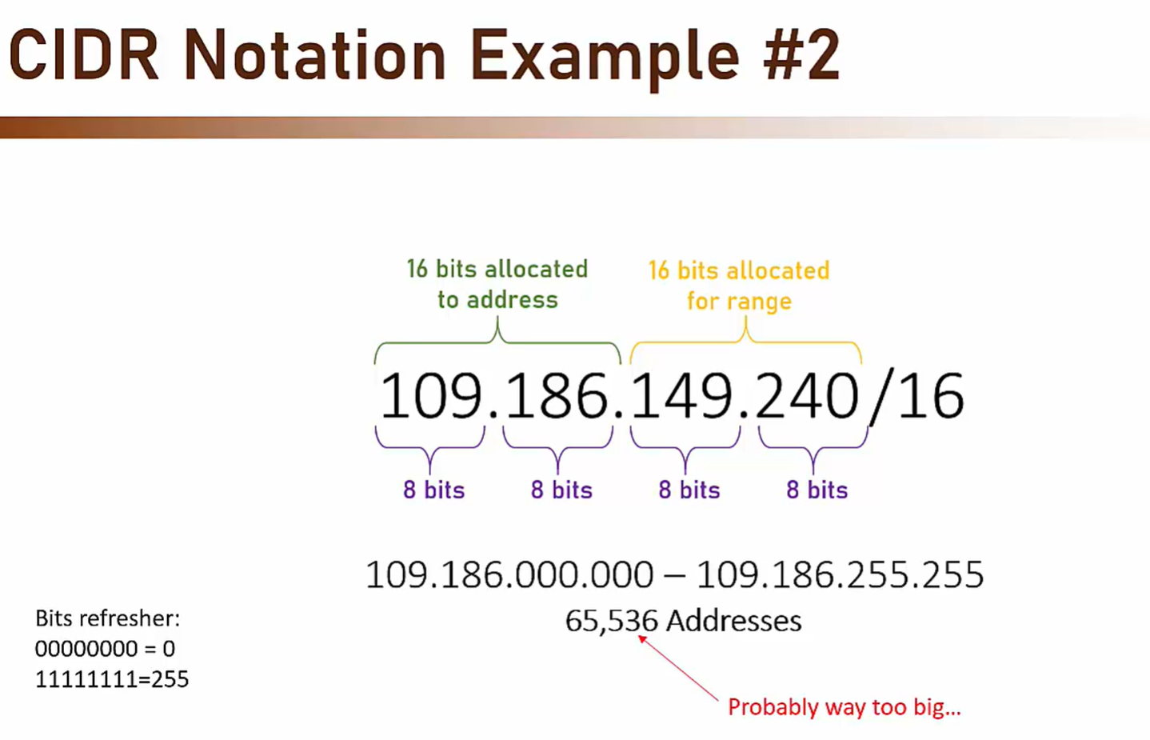

CIDR Notation Tip Another way to calculate the range size with CIDR notation is this: Size = 2^(32-Range) So, for example, in this case: 109.186.149.240/24 This is what we get: Size = 2^(32-24) = 2^8 = 256 And in this case: 109.186.149.240/20 This is what we get: Size = 2^(32-20) = 2^12 = 4096

Subnets:

• A logical segment in the VNet • Shares a subset of the VNet's IP Range • Used as a logical group of resources in the VNet • Is a must. Resources must be placed in a Subnet, cannot be placed directly in the VNet

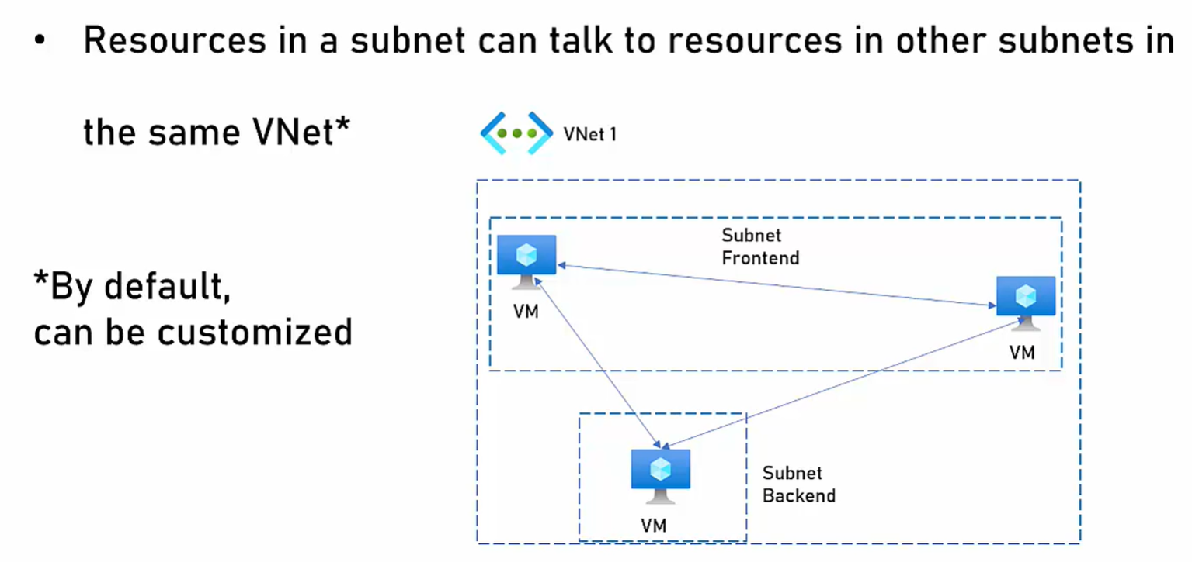Addresses of Subnets • Each Subnet gets a share of the parent VNet's IP Range • NEVER use the full range of the VNet in a Subnet • Extremely hard to modify the range later • Makes it hard to add future Subnets

Subnets are free, limit of 3000 subnets per vnet

Azure needs 5 addresses of your vnet for its own internal use, therefore you get to utilise 5 addresses less than the range in each subnet.

Network Security Group: • Usually called NSG • A gatekeeper for Subnets • Defines who can connect in and out of subnet • Think of it as a mini-firewall Should be a standard part of Subnet creation • Is free

How NSG Works? • Looks at a 5 tuple: • Source (=Where did the connection come from • Source Port (=The port the source is using) • Destination (=Where does the connection request go • Destination Port (=To which port does it want • Protocol (=TCP, UDP, Both)

How NSG Works? • Based on these 5 tuples the connection is either allowed or denied • This is called Security Rule • Each rule is assigned a number • The lower the number - the higher the priority of the rule

NSG and VMs • An NSG is automatically created and attached to every newly- created VM's network interface • By default - open RDP (on Windows) or SSH (on Linux) port to anyone MUST be handled first thing after creation

Theres a network watcher service which shows you all your vnets and subnets and everything network related that you’ve setup in a diagram format

Azure Storage:

Azure SQL:

• Managed SQL Server on Azure • Works like any other SQL Server using the same tools • Great compatibility with on-prem SQL Server • Depends on the exact Azure SQL Flavor • Offers built-in security, backups, availability and more And Flexible Pricing models

Azure SQL Database • Managed SQL Server on Azure • Single database on a single server • Automatic backups, updates, scaling • Good compatibility with on-prem SQL Server • Not all features are supported

• Security Offerings by Azure SQL DB: • IP firewall rules • Service Endpoints • SQL & Azure AD Authentication • Secure communication (TLS) • Data encrypted by default (TDE)

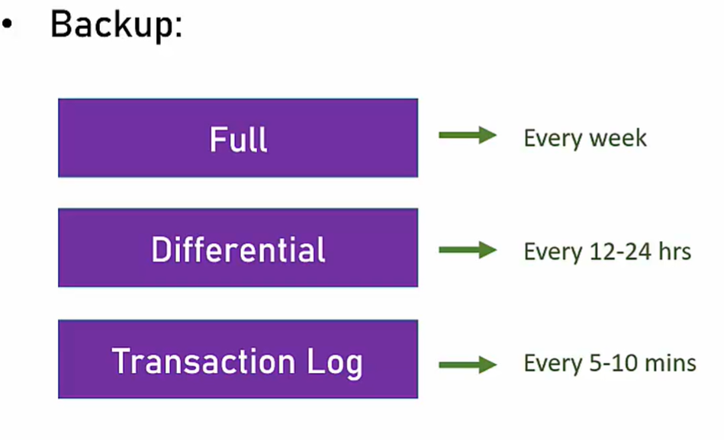

Retention period of backup data:

• Regular backup: 7-35 days (default is 7) • Long term backup: up to 10 years

• Availability: • Backup is stored in a geo-redundant storage • Active geo-replication • SLA: 99.9% - 99.995%, depends on tier and redundancy

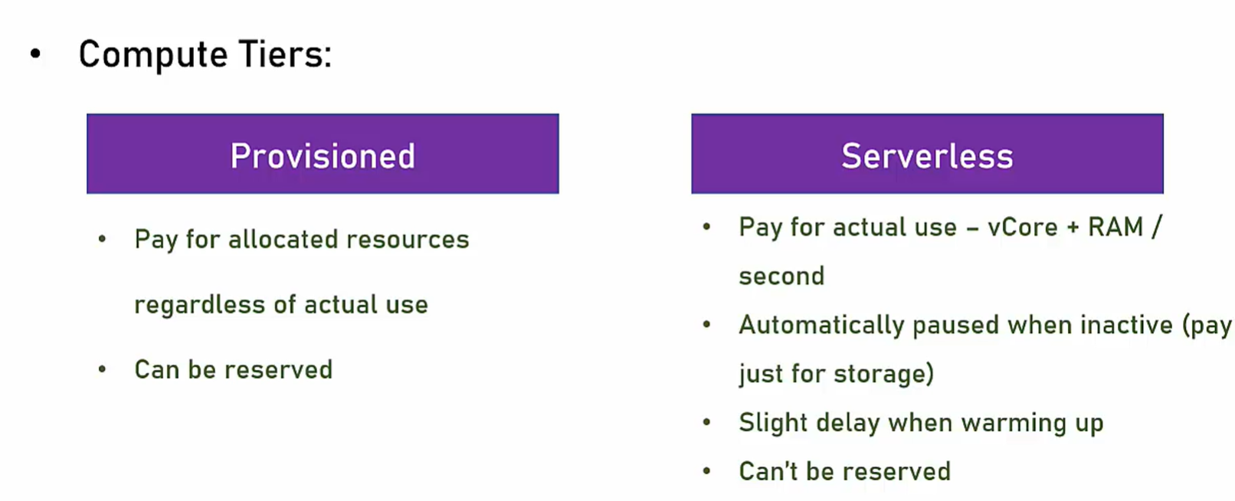SQL Database Compute tiers

Elastic Pool • Cost effective • Purchase the compute resources you need, not the database

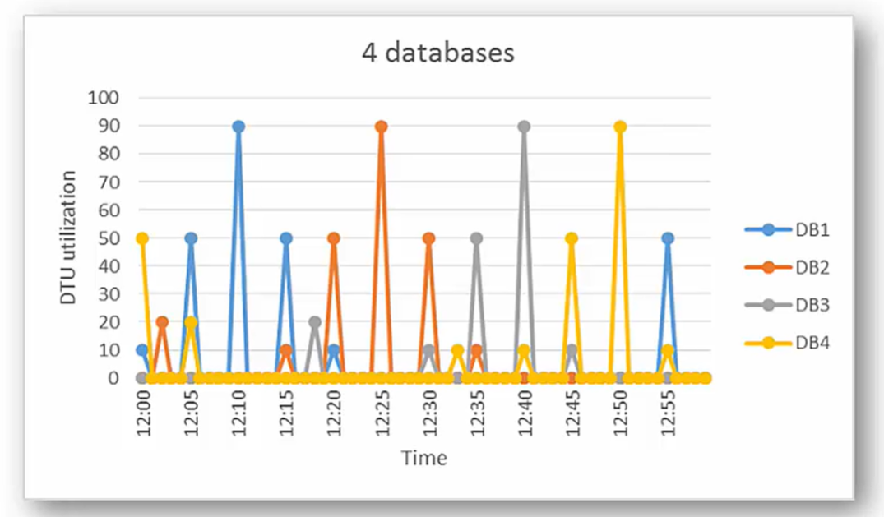If you have 4 databases that spike at different times, they can use the same resources and share them amongst themselves, it increases resource utilisation and is very cost effective.

Managed Instance: • Closer to the on-prem SQL Server • Near 100% compatible with on-prem SQL • Can be deployed to VNet • Business model close to on-prem one

Managed Instance • Main differences: • No active geo-replication • SLA: 99.99% • Supports built-in functions, Runs CLR Code and No Autoscaling and tuning and No availability Zones, no Serverless tier and No Hyperscale

Azure SQL Pricing (Very Complicated)

Gist: Managed Instance is very expensive, upwards of $1500 per month

Azure SQL Database with DTU model very cheap like $30 per month

Single DB max price around $6000 per month for Azure SQL DB

Pick right tier and size according to your needs

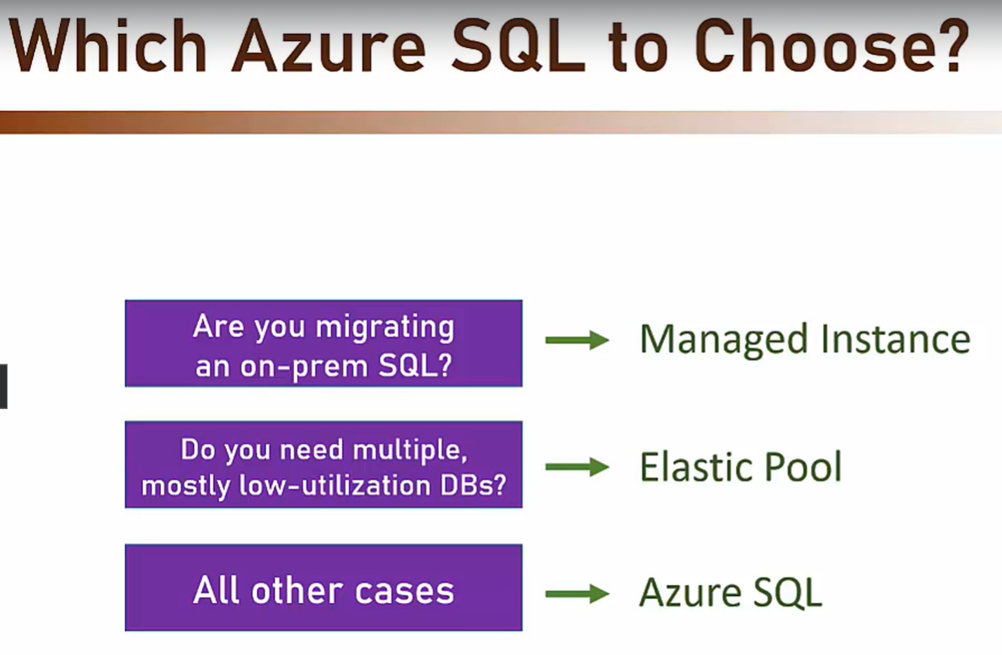

**Azure Active Directory/ Entra ID:**

Identity and access management cloud service

**Has advanced features like:**

* MFA
* Conditional Access
* Device Management
* Hybrid Identity
* Identity Protection
* Monitoring and reports
* Many more

Control access to azure resources by setting up users, groups and roles. Use Entra ID to add authentication to our own apps

Azure Entra ID integrates with 2800 apps. Very secure

Tenant AKA Directory: Specific instance of AAD containing accounts and groups. Not part of Subscription heirarchy. Exists besides a subscription. Can connect and tenant to multiple subscriptions.

Global Administrator Role: Most powerful role.

Sign in logs menu shows logs of current tenant use. Authentication requirement shows what kind of auth was used.

A Security group is a group that is managed by AAD and can hold users from AAD

**Azure AD License:**

• Azure AD Licenses have great effect on the functionality and price

of Azure AD

• Important to understand the differences and recommend the right

Solution

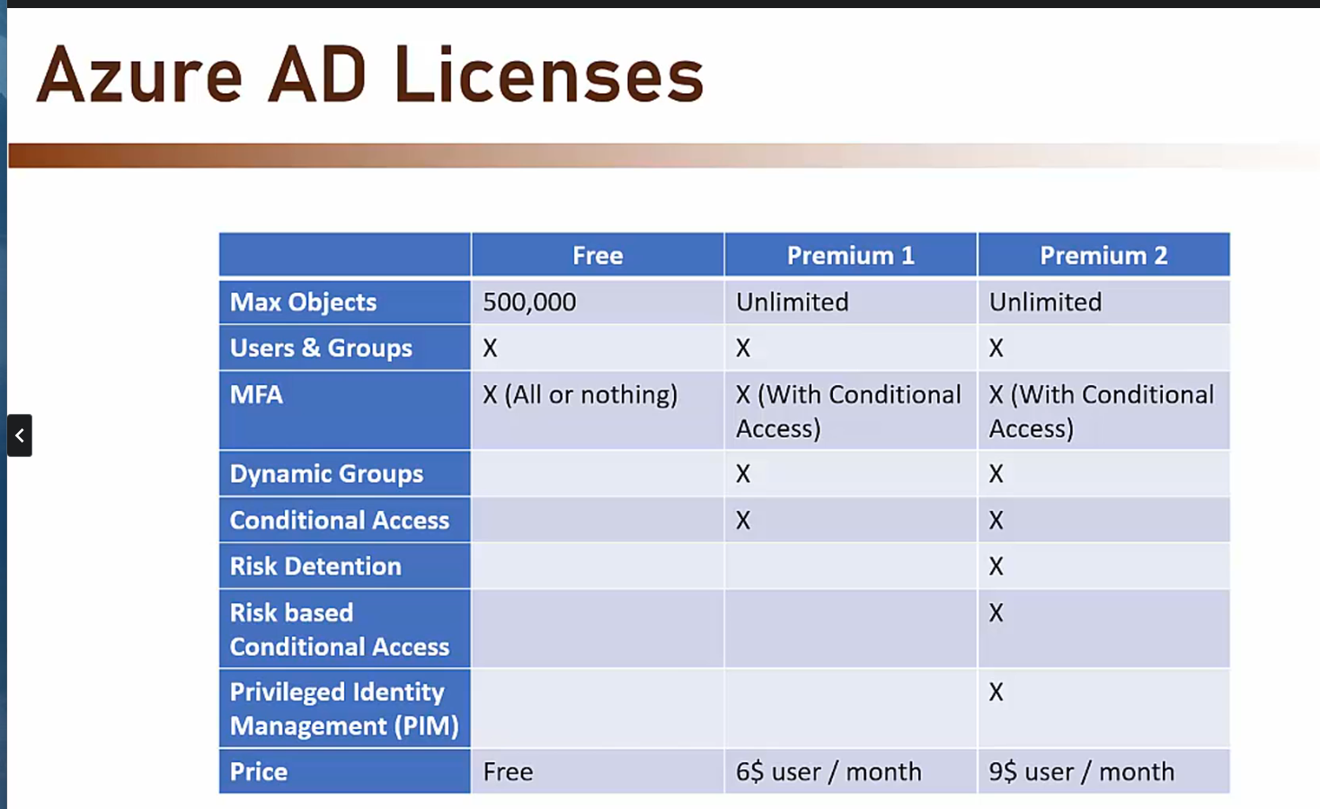

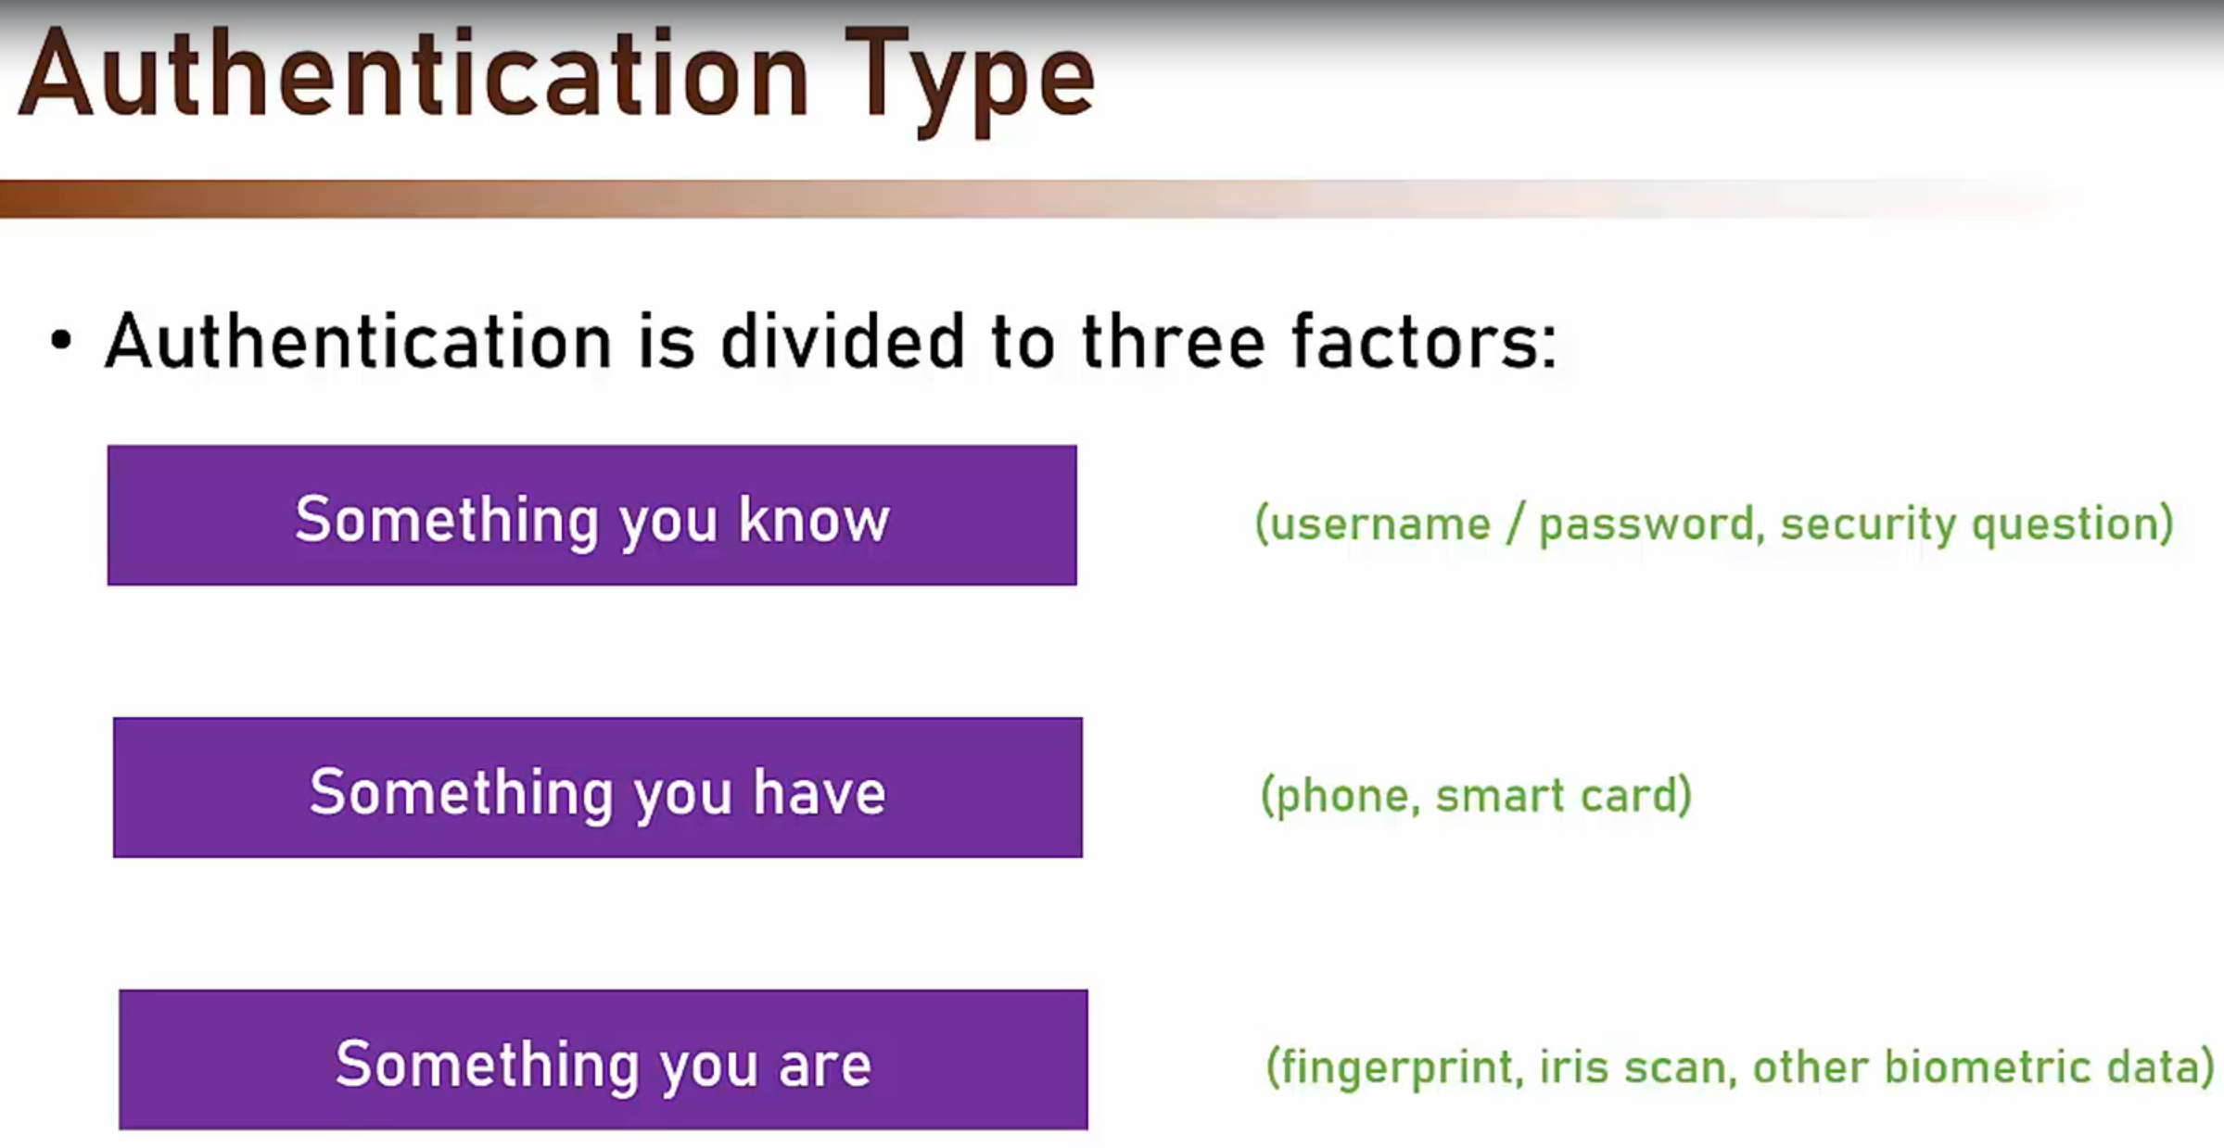

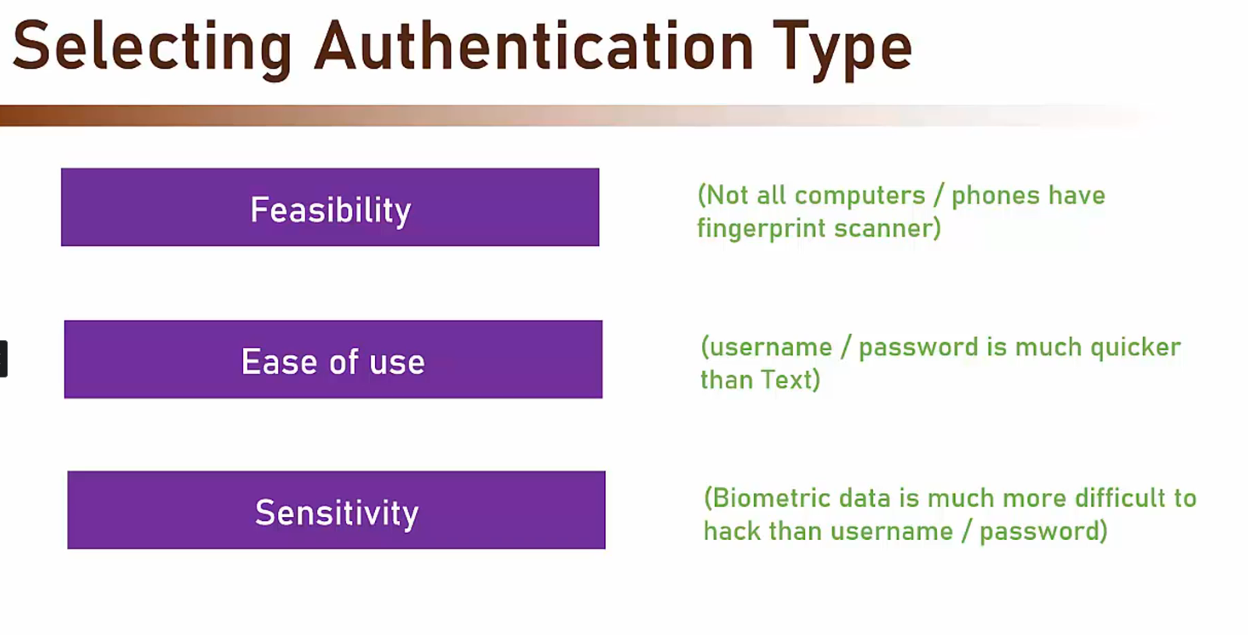

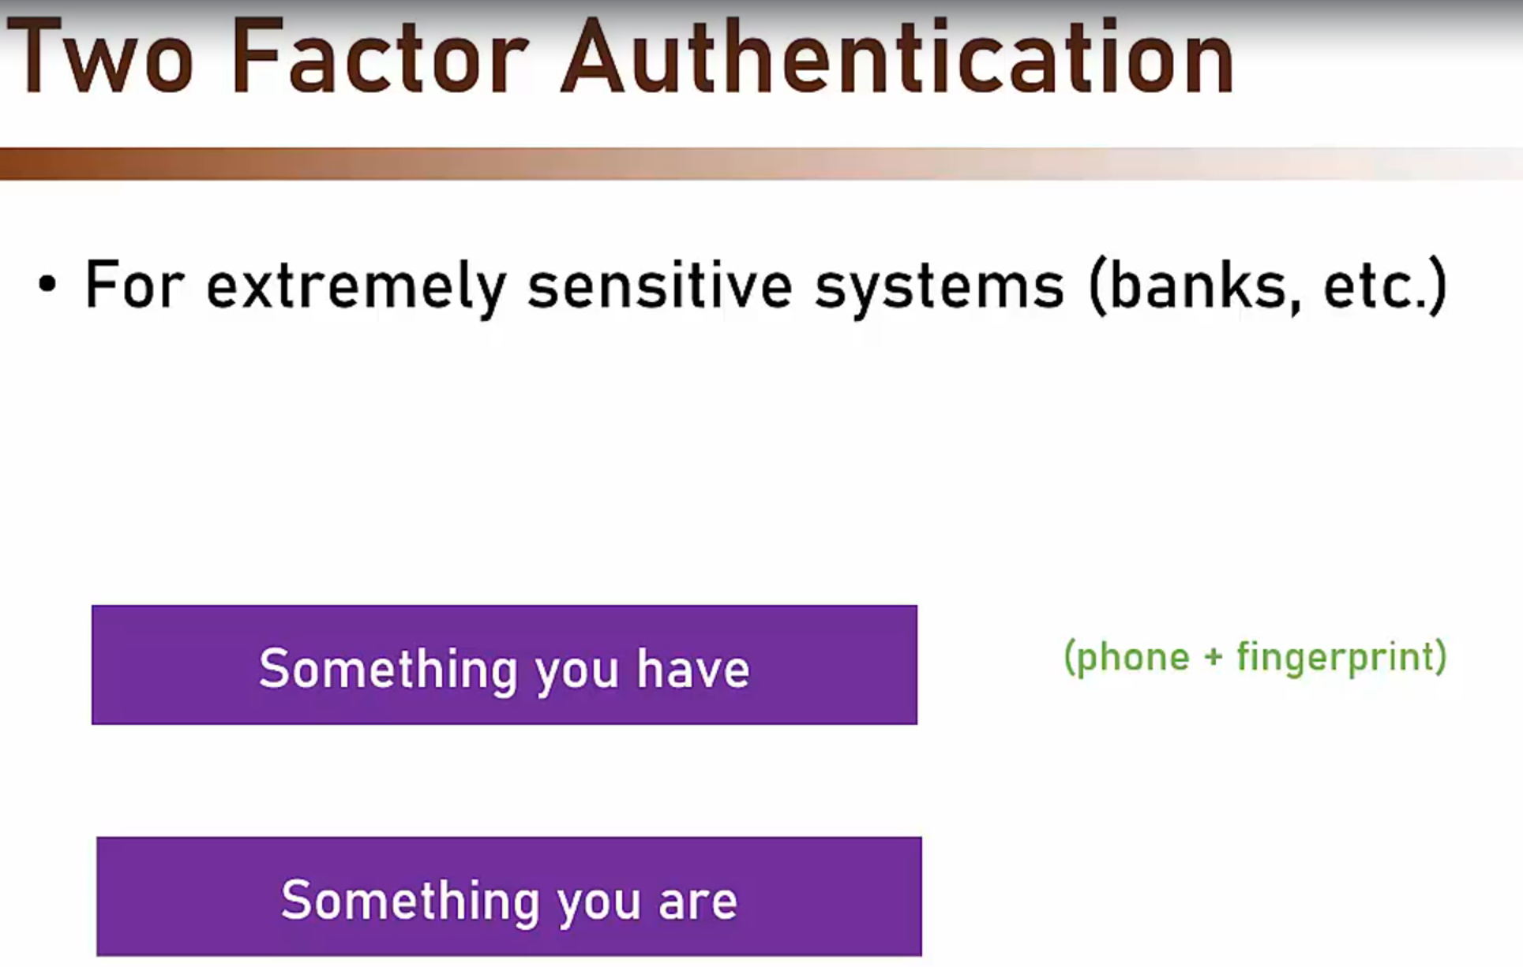

**Azure AD Security Defaults**

• Increases protection of the organization in the Free tier

• Adds preconfigured security settings:

• Requiring all users to use MFA (block 99.9% of account

compromises)

• Blocks legacy authentication

• And more...

• No additional cost (so...still free ©)

• For more fine-grained management - use Conditional Access (P1)

**RBAC in Azure**

• In order to perform any operation, or access any data in Azure you

have to have the appropriate role

• If you want to:

• Create resource groups

• Access data in SQL

• See metrics of App Service

• ... then you have to have the right role

• If you don't - you'll get an empty portal

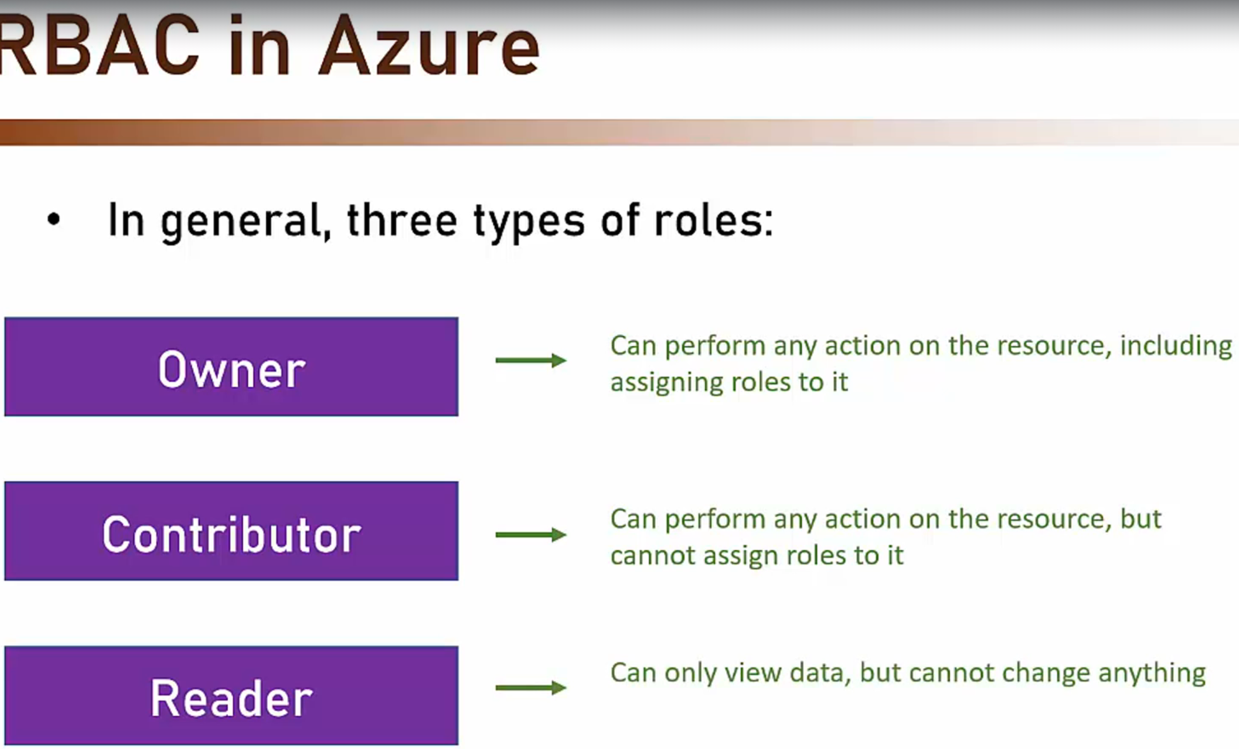

**Managed Identities**

•

Two types of Managed Identities:

System assigned - Managed by Azure, tied to the resource's

lifecycle (when the resource is deleted - so is the identity)

• User assigned - Managed by the user. Can be assigned to

multiple resources, not tied to any lifecycle

• **Resources that can be assigned Managed Identity**:

• App Service

• Virtual Machine

• Event Grid

•Function

And more...

• **Resources that can be authorized using Managed Identity:**

• SQL

• Event Hubs

• Service Bus

• Storage

• Key Vault

• And more...

**App Registration**

• Authorization Server should be familiar with the Resource

Server (API)

Resource Server must register itself with the Authorization

Server. This means if user wants to login via google, your app(RS) should be registered with google (AS)

**Azure AD B2C**

• Identity-as-a-service for your application

• A Business-to-Customer (B2C) service

Enables integrating identity services in your app

• Works with various identity providers

• Provides various user flows

•

Enables customization

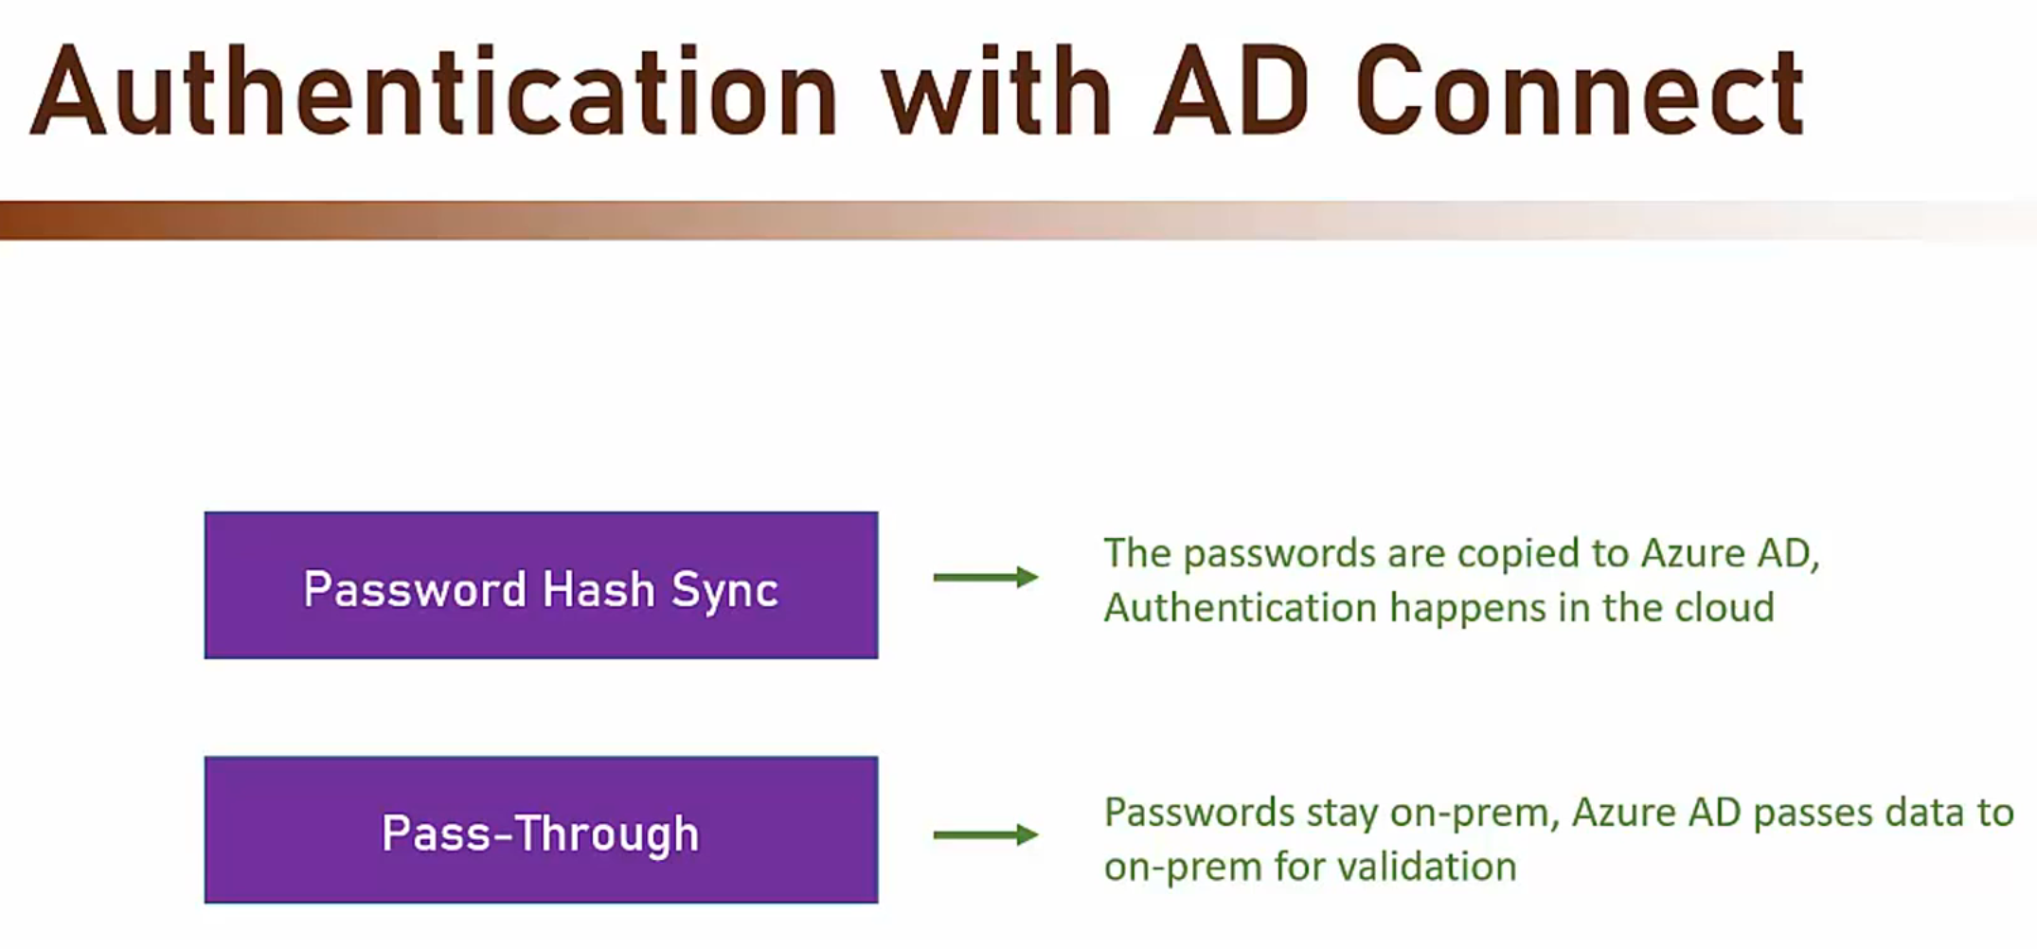

Password Hash Sync and Pass-Through for AD Connect which is a service to sync on prem and AAD directories